**Iteration** **2**

**Group members:**

Kenny Aranda

Artem Babakov

Justin Adkison

1. **Sequence Diagrams:**

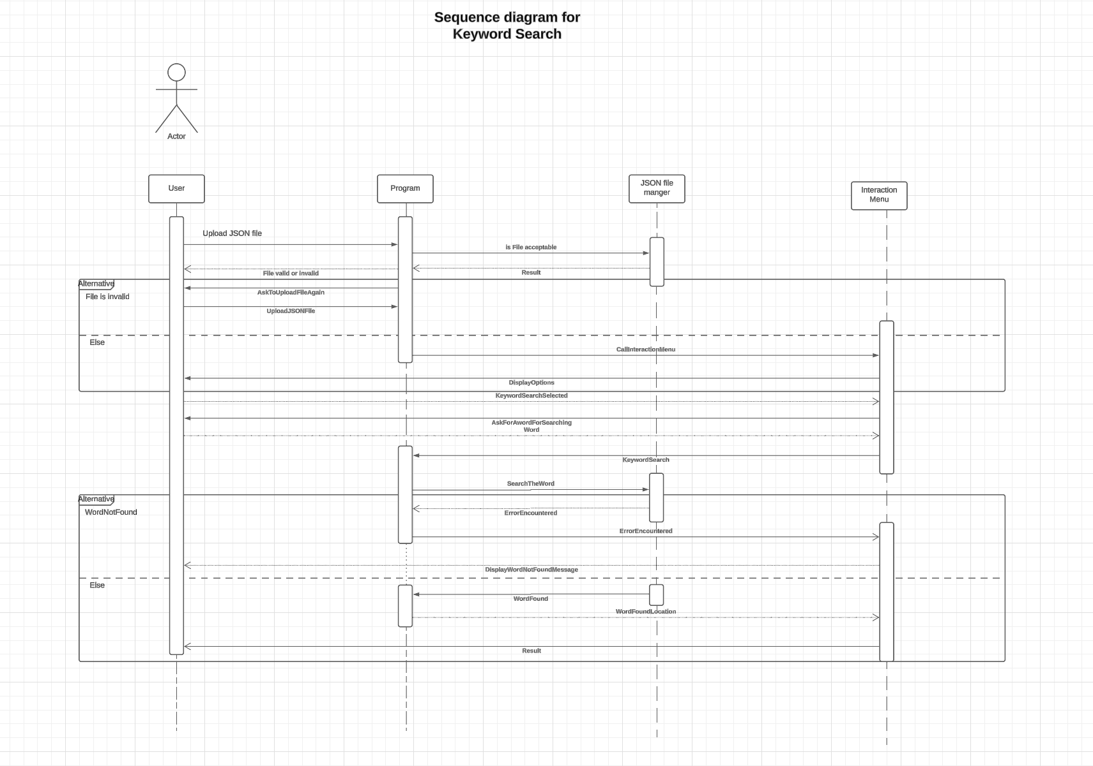

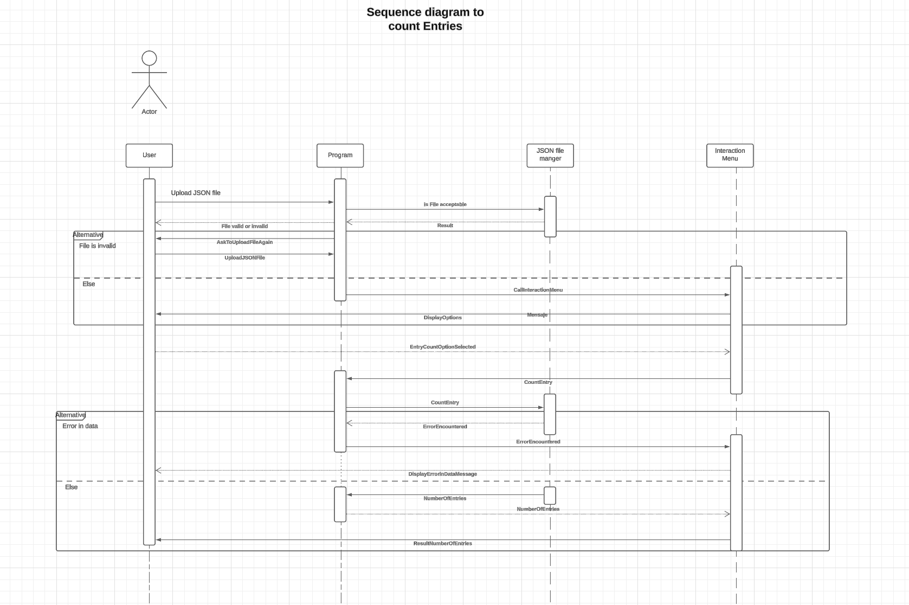

1. **Use Cases:**

**File Upload**

|  |  |
| --- | --- |
| **Actor** | **User** |
| Description | User provides a JSON file to the program for analysis. |
| Pre-conditions | User has access to the file upload feature |
| **Step** | **Description** |
| **1. User Uploads File** | User Selects the JSON file to upload to upload for analysis |
| **2. System Validates File** | System checks the validity and size of the uploaded file. If Invalid or exceeds size limit, display error message and allow user to re-submit |

**Output Fields**

|  |  |
| --- | --- |
| **Actor** | **User** |
| Description | After successful upload, user navigates through the menu for output fields. |
| Pre-conditions | File upload is successful. |
| **Step** | **Description** |
| **1. User Navigates menu** | User selects the menu option for output fields. |
| **2. System displays options** | System presents options for output fields to the user. |

**Data Fetching**

|  |  |
| --- | --- |
| **Actor** | **User** |
| Description | Users use interface controls to fetch specific data, including entry counts and keyword searches. |
| Pre-conditions | User has uploaded a valid JSON file. |
| **Step** | **Description** |
| **1. User selects data fetch** | User utilizes interface controls to select data fetching options. |
| **2. System retrieves data** | System fetches the requested data based on user's input. |
| **3. System displays results** | System presents the fetched data to the user. |

**Reset Functionality**

|  |  |
| --- | --- |
| **Actor** | **User** |
| Description | User initiates a reset action to go back to the initial state for uploading a new file. |
| Pre-conditions | Users are in a state where they can perform a reset action. |
| **Step** | **Description** |
| **1. User initiates reset** | User triggers the reset action. |
| **2. System Validates File** | System clears all temporary data and returns to initial state. |

**Case Sensitive Searching**

|  |  |
| --- | --- |
| **Actor** | **User** |
| Description | User selects whether they want the search to be case-sensitive when fetching data. |
| Pre-conditions | User is performing a data fetch operation. |
| **Step** | **Description** |
| **1. User selects search type** | User selects whether the search should be case-sensitive or not. |
| **2. System performs search** | The system executes the data fetch operation according to user's selection. |
| **3. System displays results** | System presents the fetched data to the user. |

**View All Functionality**

|  |  |
| --- | --- |
| **Actor** | **User** |
| Description | User can select to view all data within the JSON file at once. |
| Pre-conditions | User has uploaded a valid JSON file. |
| **Step** | **Description** |
| **1. User selects view all** | User chooses the option to view all data within the JSON file. |
| **2. System displays all data** | System presents all data from the JSON file to the user. |

1. **UML Use Case Diagram:**
2. **UML Class Diagram:**
3. **Commit Log:**